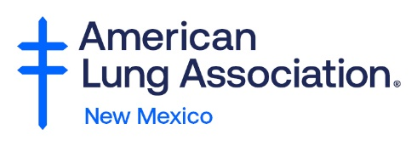

Construction Industries Division
Regulation and Licensing Department
5500 San Antonio Drive NE, Suite F
Albuquerque, NM 87109
Attention: Public Comments
Re: 2021 Energy Conservation Codes

On behalf of the American Lung Association, I would like to offer these comments in support to adopt the 2021 Energy Conservation Codes.
New Mexico has dangerous levels of unhealthy air in the United States. The American Lung Association 2023 "State of the Air" report shows 51% of New Mexicans live in counties impacted by unhealthy levels of ozone and/or particle pollution. Air pollution contributes to respiratory and cardiovascular impacts including increased asthma attacks, worsened COPD, heart attacks and strokes, and premature death. Vulnerable populations such as children, the elderly, people of color, and low-income individuals are most at risk from these health harms.
The American Lung Association in New Mexico supports widespread transportation electrification (TE) as a first step to reduce greenhouse gas emissions, improve air quality, and protect the health of all New Mexicans. Our electric vehicle report, “Zeroing in on Healthy Air” found that the transportation sector is the leading contributor to our air pollution challenges, especially in at-risk communities. Adopting building energy codes that enable the growth of the zero-emission transportation sector could yield $3 billion in public health benefits just here in New Mexico between now and 2050.

Improving poor air quality in New Mexico requires bold investments in electric cars, buses and medium/heavy-duty trucks coupled with increasing levels of non-combustion, renewable energy sources - these policies are widely supported among New Mexico constituents. To make these health savings a reality, we urge adoption in electric vehicle charging infrastructure provisions in the 2021 IECC in order to ensure higher EV adoption can be done cost-effectively and safely.
As a leading public health organization, we support the adoption of stronger energy codes. Better energy codes mean cleaner fresher air and improved health outcomes.

Thank you for your consideration of our comments.

Sincerely,
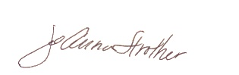
JoAnna Strother
Senior Advocacy Director American Lung Association

