Renewals Quick Reference Guide
Public Accountancy Board

Table of Contents
Overview 3
Accessing a License for Renewal 3
Renewal Steps 5
Payment Gateway 14
Checking Renewals Submissions 16

Overview
For the New Mexico Regulation and Licensing Department, this Renewals Quick Reference Guide will explain how to use the portal to renew a license.

Accessing a License for Renewal
- Log in to the RLD Licensing portal.
- On the home page, you will see the My Licenses section. This will display a list of all your applied licenses.
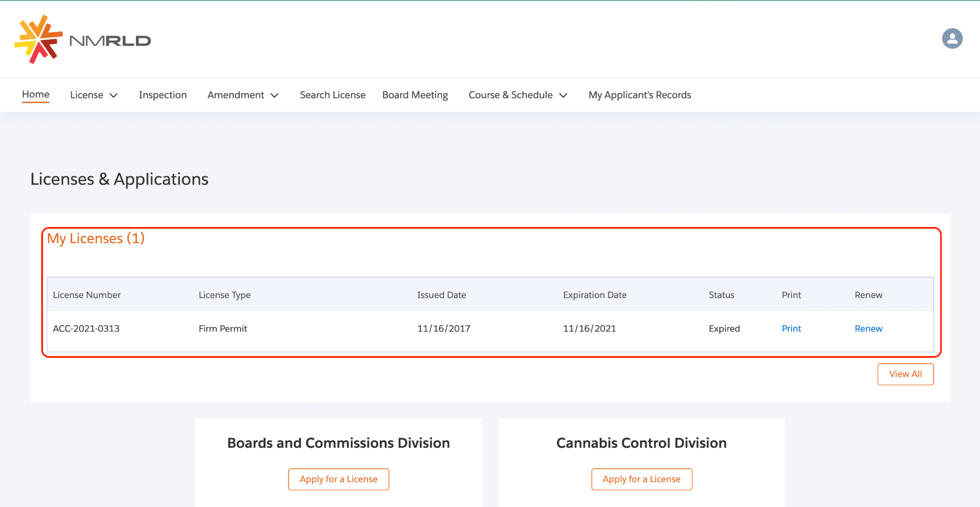

Note: If you see the My Licenses section on your home page, you can access it through the License > My Licenses drop-down list.
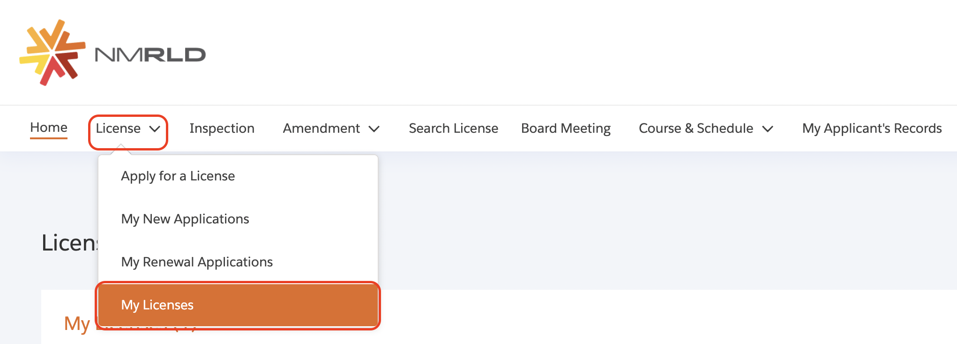
- Click View All to see the complete list.
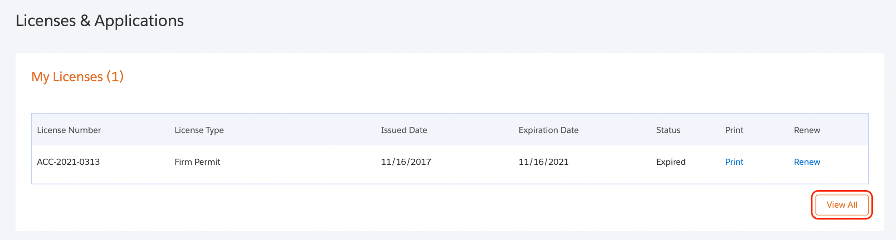
- For the license you want to renew, click the Renew link under the Renew column in blue. The renewal application will appear.
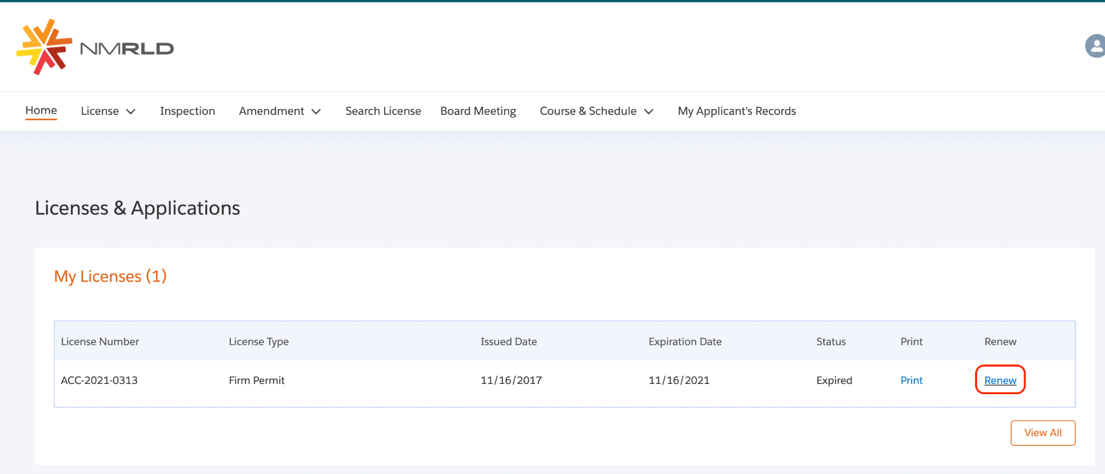

Renewal Steps
You must fill in the details for all steps before submitting your renewal application.
- In the Getting Started step, read the information carefully, then click Save & Next.
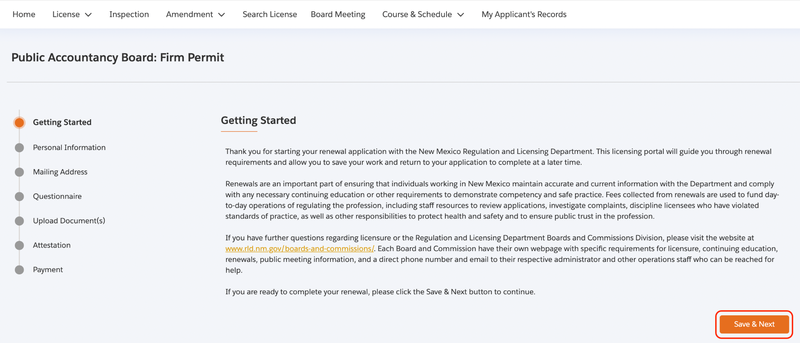
- In the Personal Information step, your information will be pre-populated. However, if you need to edit the details, click on My Profile. The renewal application will then open the My Profile page.
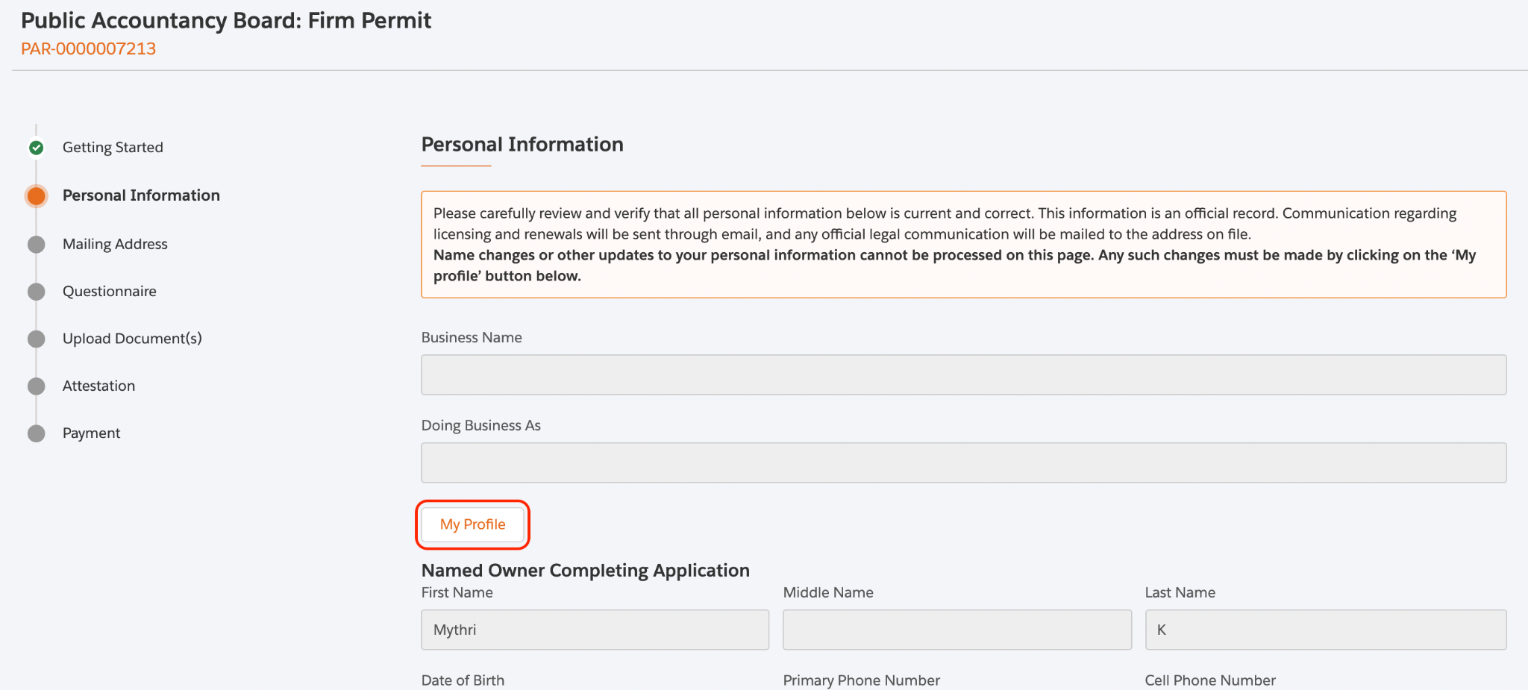
  - Scroll to the bottom of the My Profile page and click Edit.
  - Update the Email Address and click Save.
You will receive an email requesting confirmation about changing the email address. Once you confirm, the RLD application will update your email address.
Note: You cannot update any other information in your profile except the email address. And you can only update your email address once.
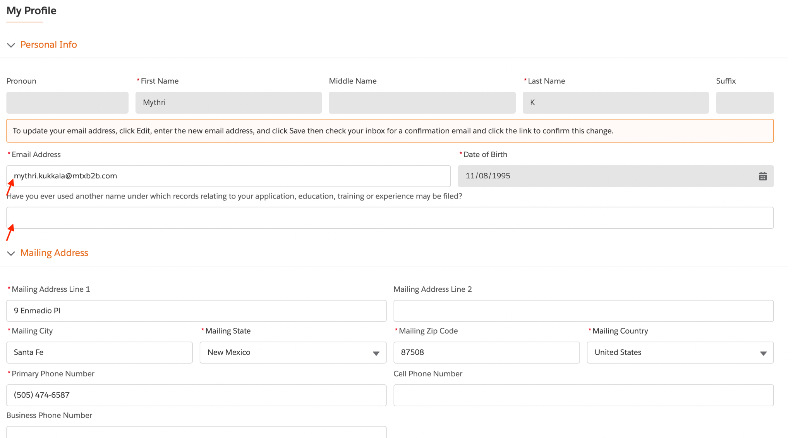
  - When complete, click the back arrow of your browser to return to the renewal form.
Note: The renewal form will open from the Getting Started step. You must click Save & Next to navigate to the Mailing Address step.

- In the Mailing Address step, update the address details, if required, and click Save & Next.
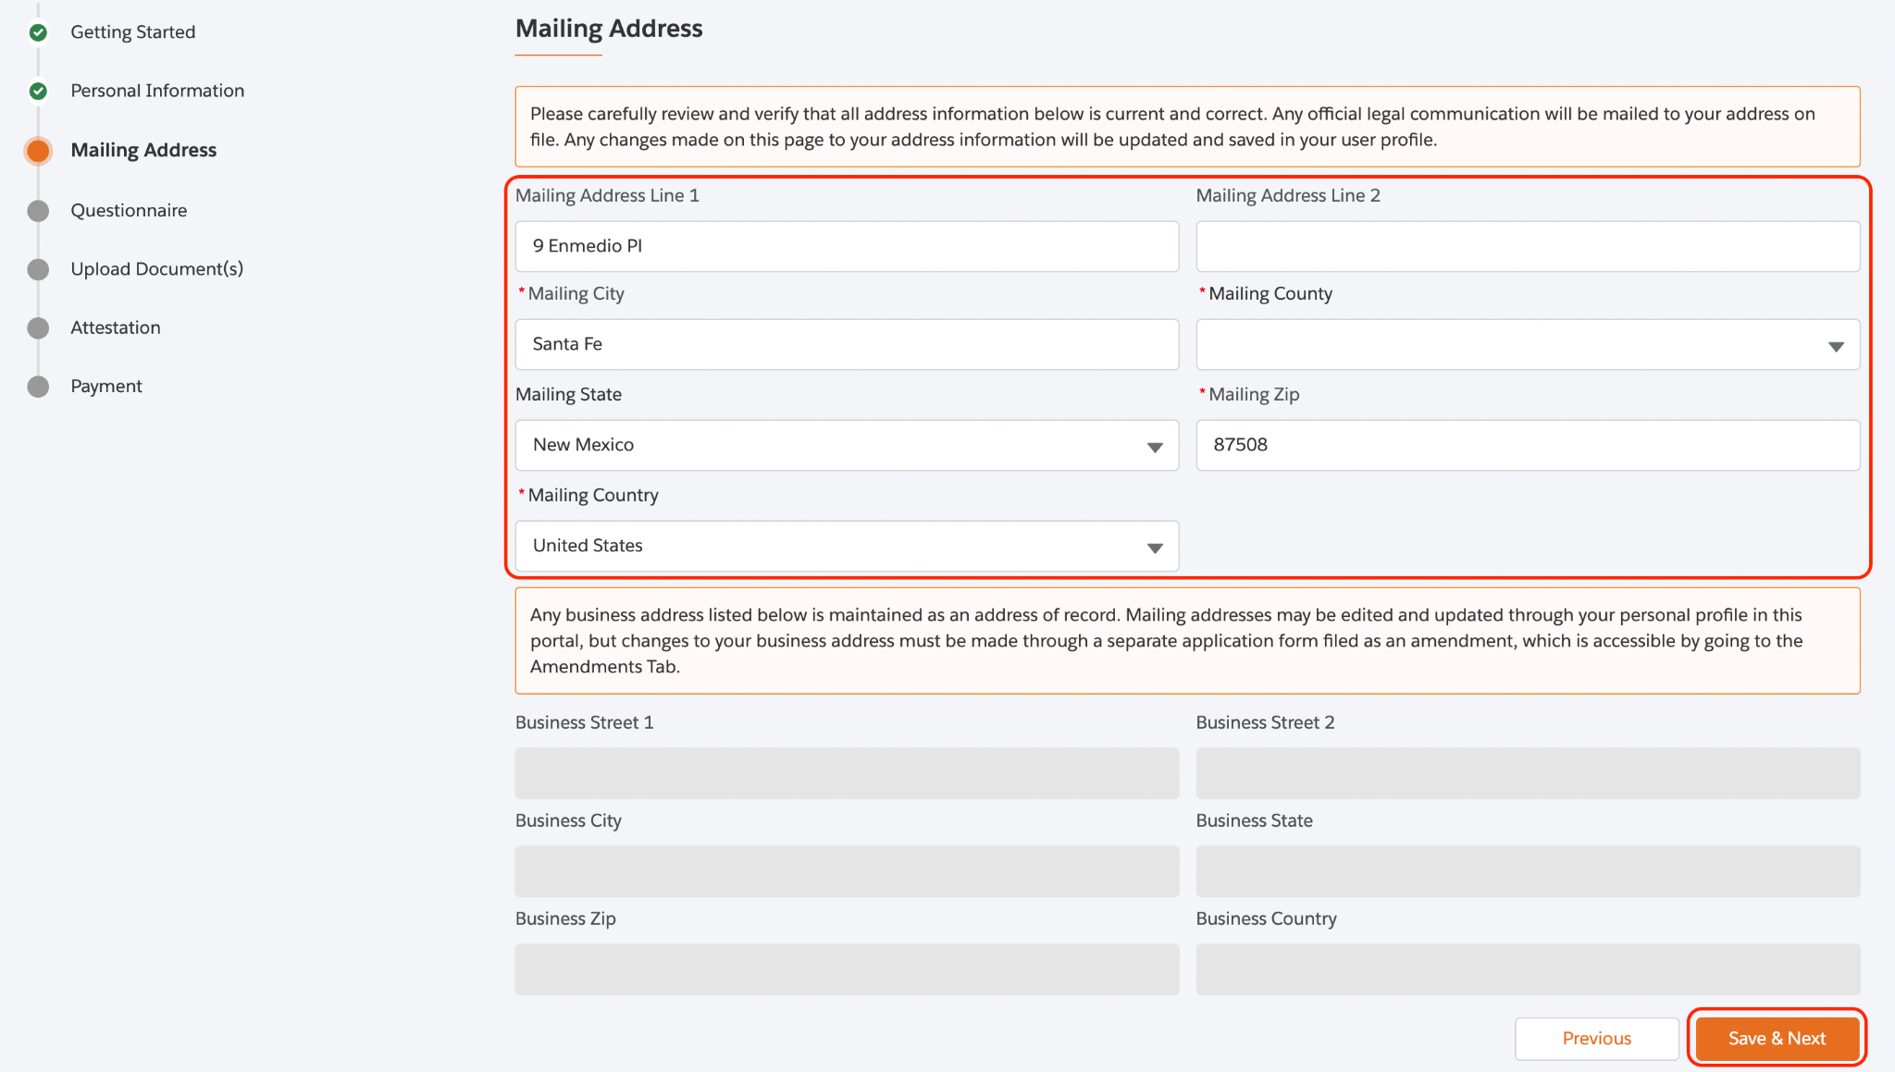
Note: If you want to update your business address, you must raise an amendment request. To raise an amendment, click the Amendments menu and click License Address Change.
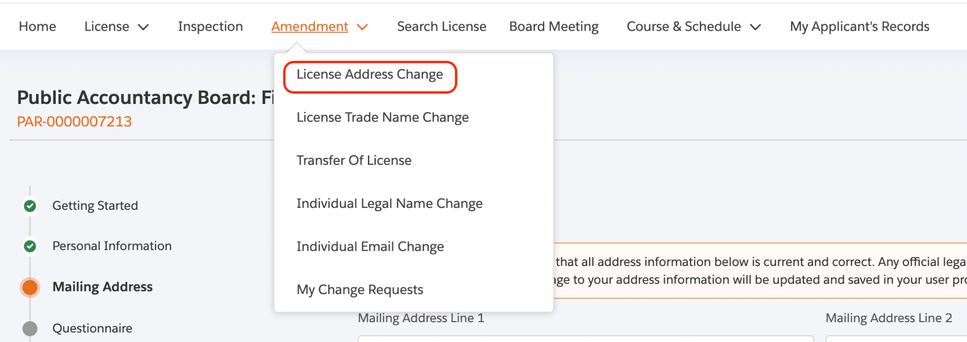
- Once complete, click Save & Next.
- In the Questionnaire step, you must answer Yes or No, and provide additional details, if required.
  - Select Yes or No for the question “Has your registration type changed since your last renewal?”
    - If you select Yes, then you will be prompted to select an option for the Type of Firm Business Registration drop-down list.
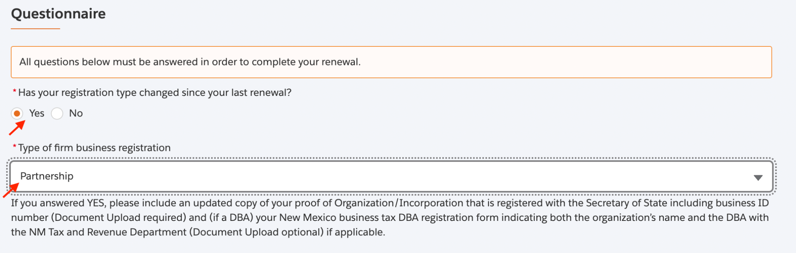
  - Select Yes or No for the question “Has the firm’s ownership changed since your last renewal?”
    - If you answer Yes, you must upload a document with details about ownership changes.
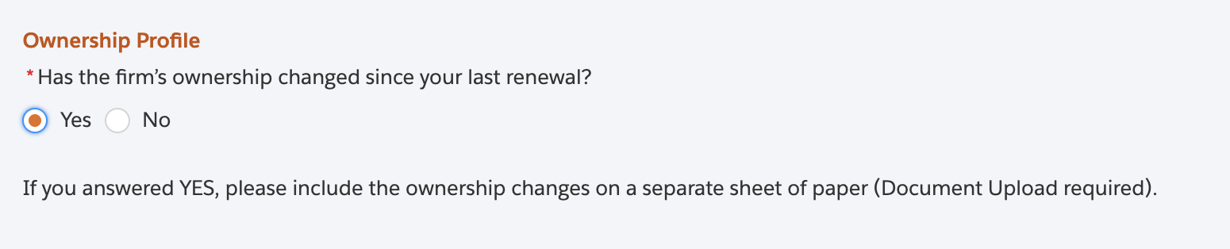
  - Select Yes or No for the question “Is your firm EXEMPT from a peer review? (see below requirement under Peer Review Statement)”.

    - If you have selected Yes, enter the list of services your firm provides in the “If you answered YES to the above question, list the services your firm provides below:” field.
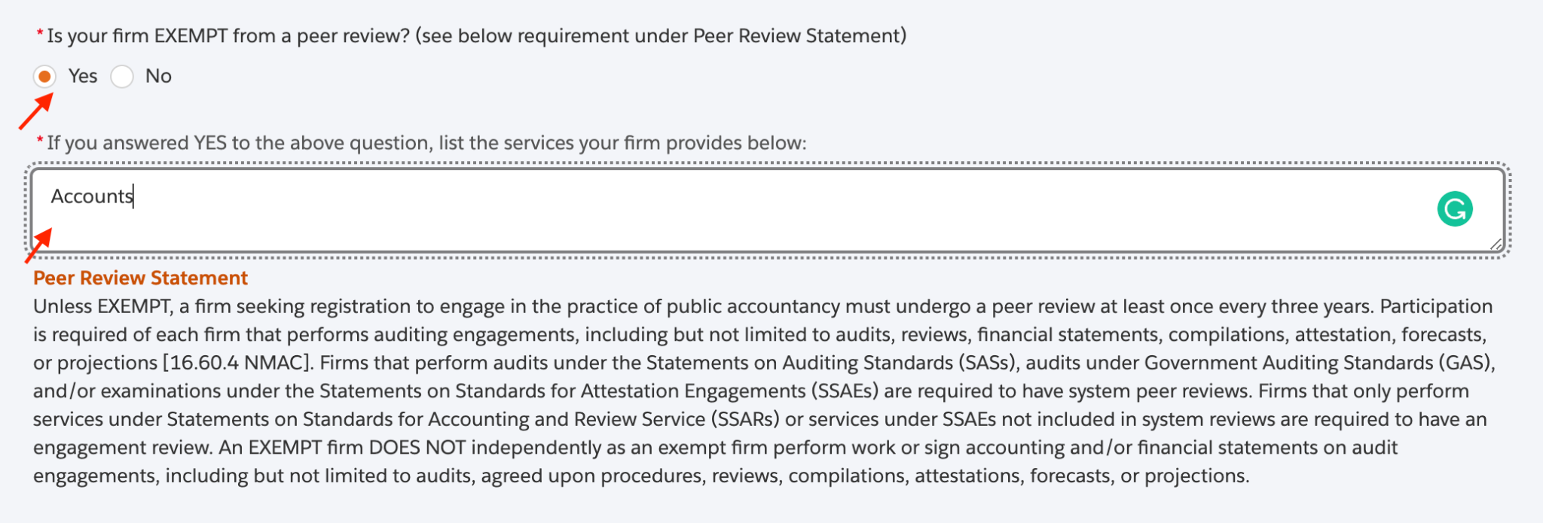
    - If you have selected No, then select the date for the “The firm’s peer review due date” field.
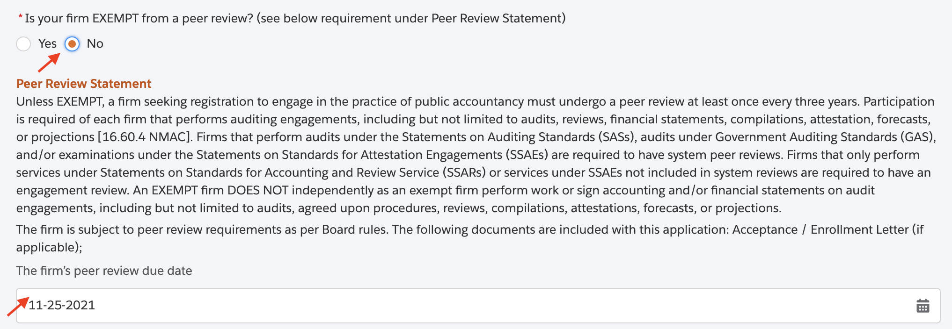
    - If you have selected Yes for the question “Have you applied and been granted a peer review extension?”, select the Extention Date.
  - For the Compliance Certification questions, read each question carefully and answer Yes, No, or N/A, as applicable.

Note: If you have answered No to any question in the Compliance Certification section, your renewal application will be kept on hold.
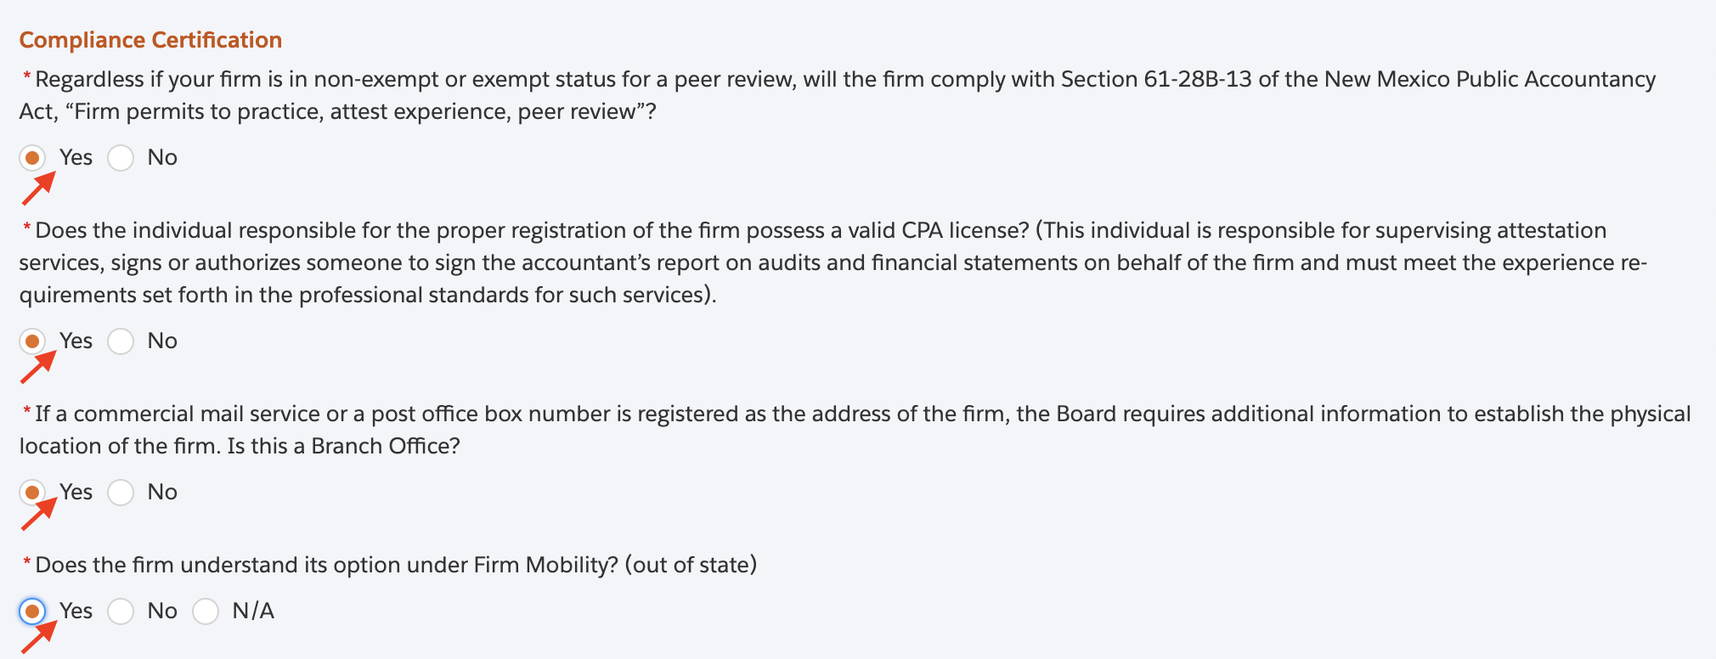
  - Fill in the details for Other Office Locations, if available.
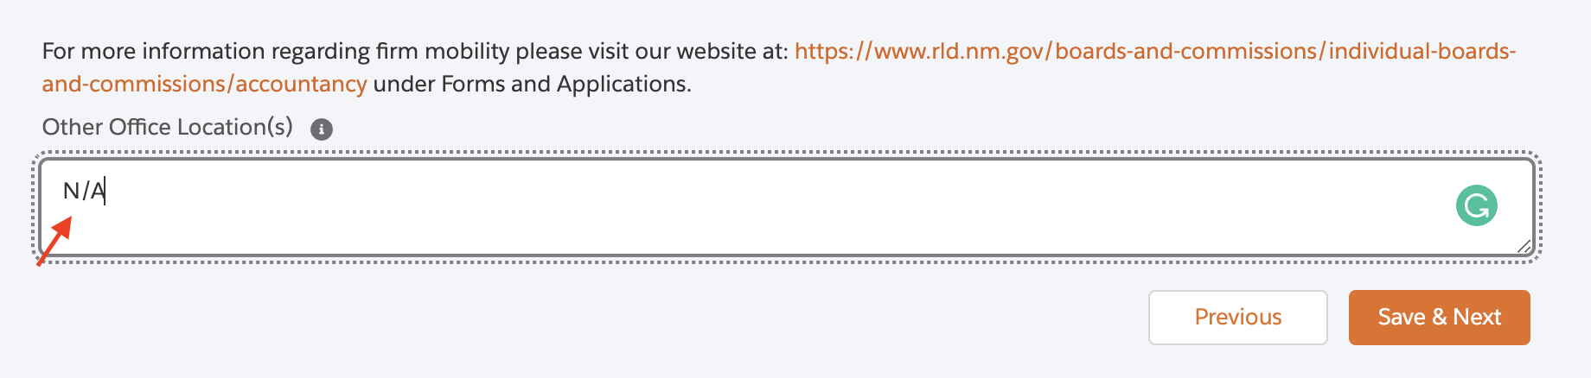
- Once done, click Save & Next.

- In the Upload Document(s) step, click the Upload a New File icon to upload new documents or click the Select Existing File icon to select already uploaded documents. The document names with a red asterisk (*) are mandatory.
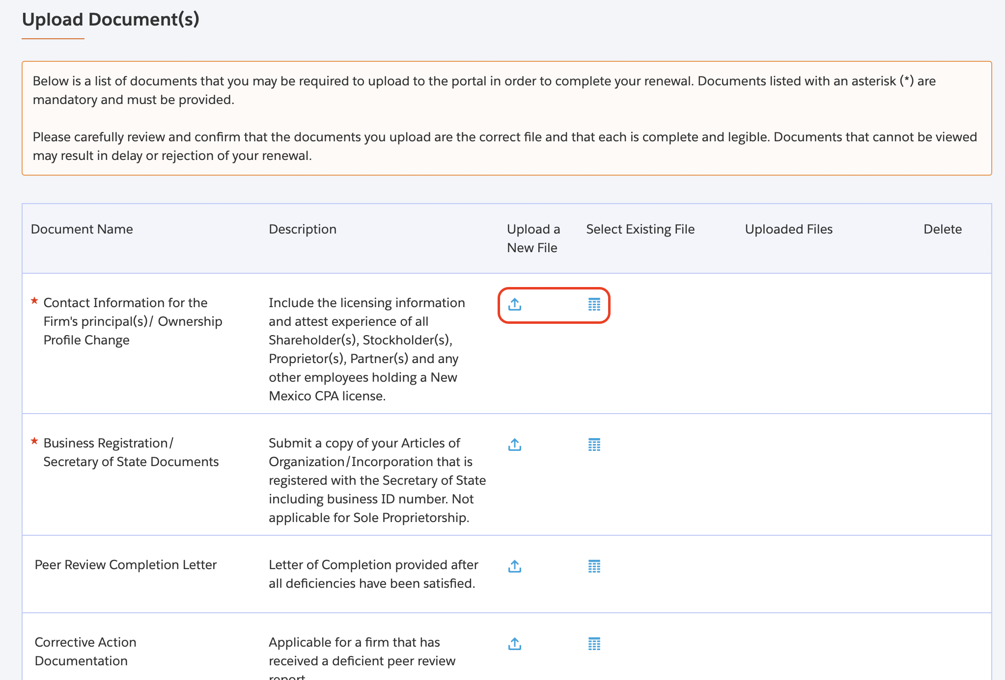
  - If you click on Upload Files, the following screen will appear.
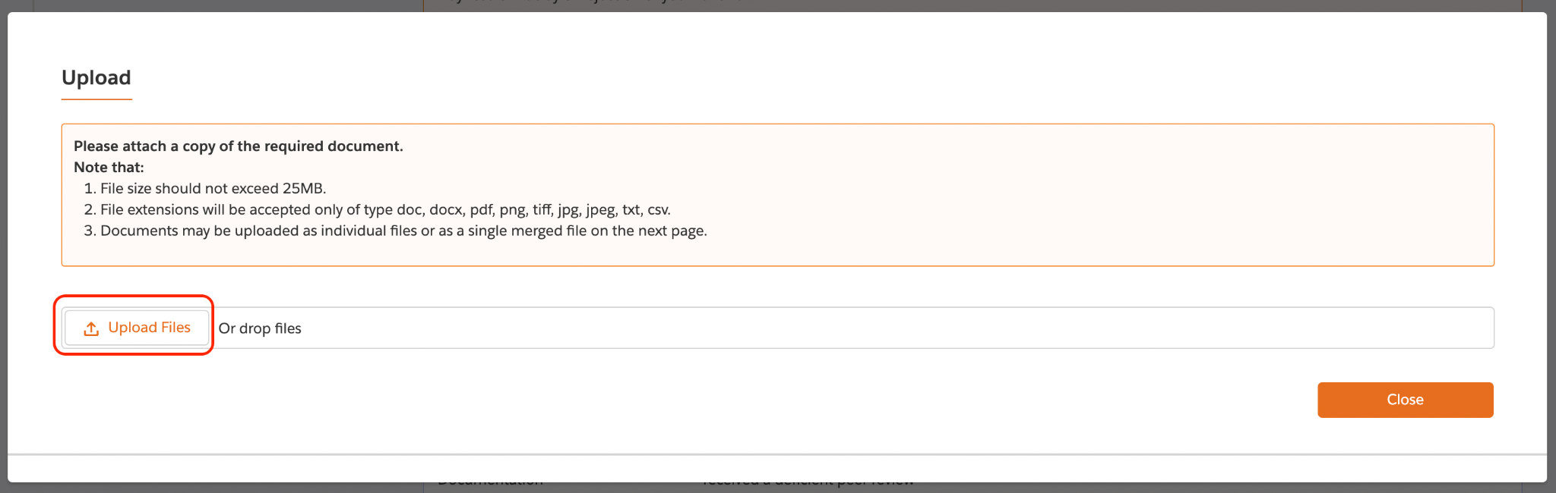

  - Click Upload Files, select the file, then click Done and click Close.
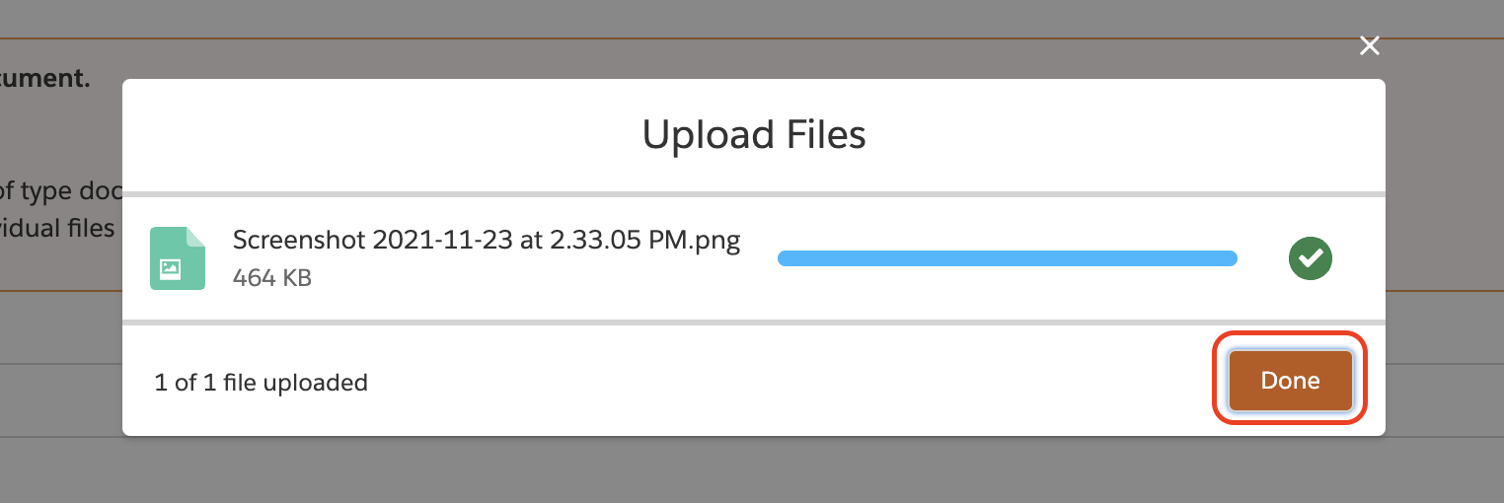
  - If you click on Select Existing, the following screen will appear. Click Use to select the required file.
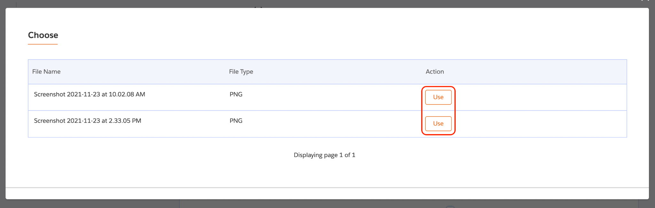
  - Click Yes.
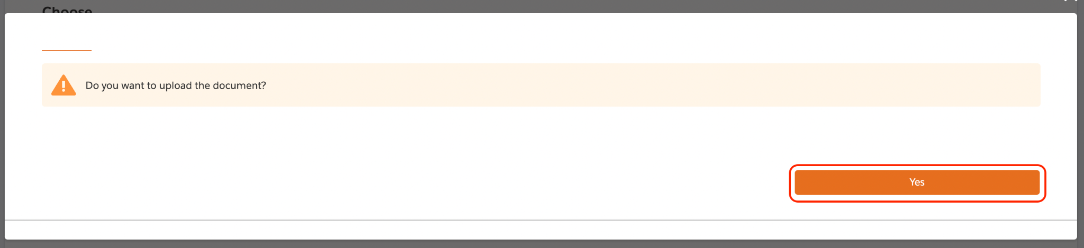
- Once all documents are uploaded, click Save & Next.

- Select the Attestation checkbox to give your consent, enter your name in the Attestation Signature field, and click Save & Next.
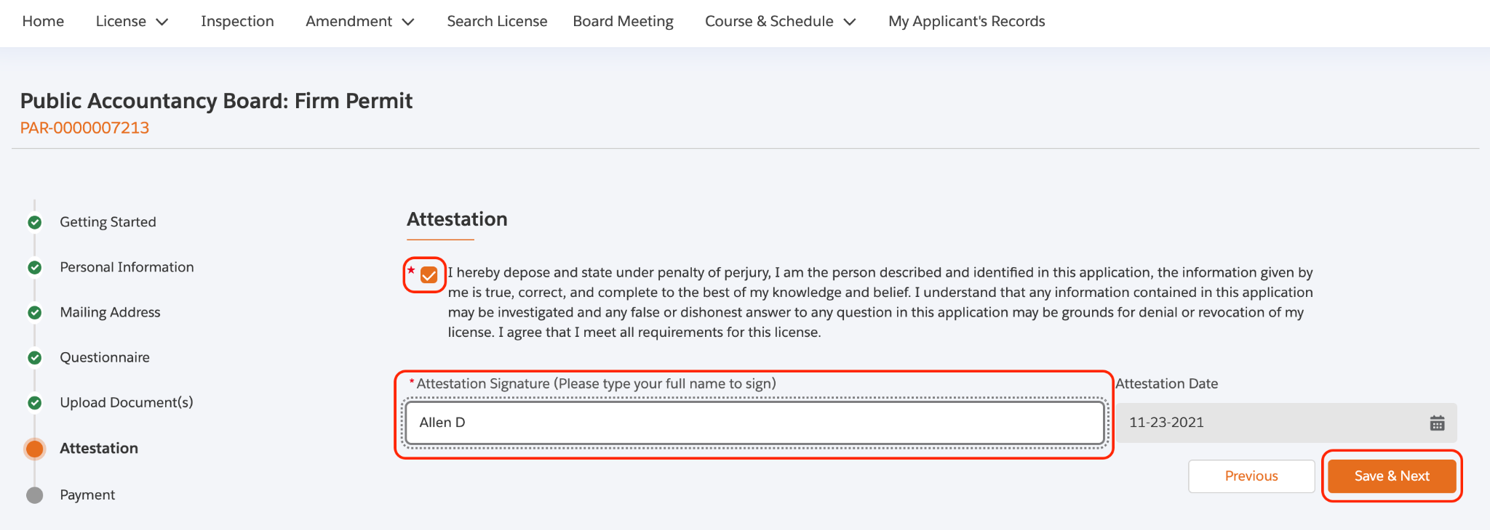
- Read the information in orange and then select a payment mode from the Mode of Payment drop-down.
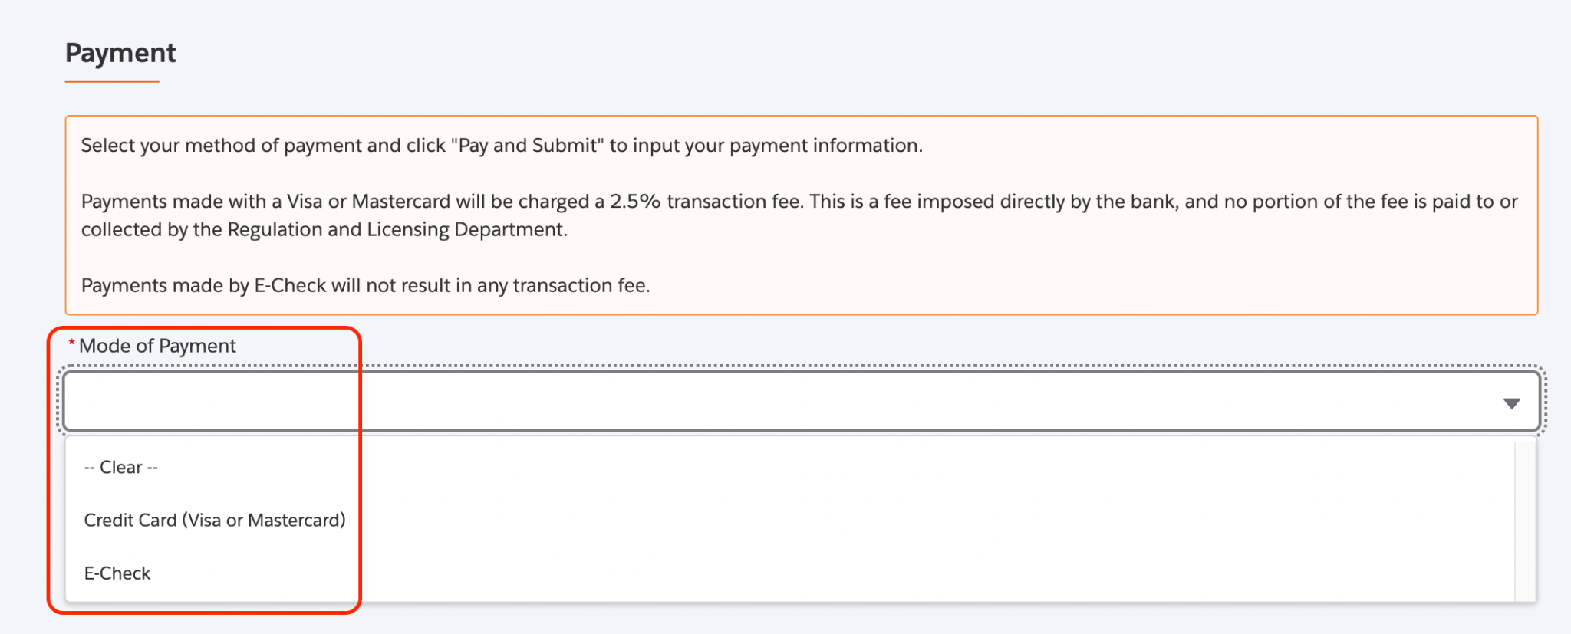
- Click Pay and Submit.
Note: You will be redirected to the following Payment Gateway screen. Payment is a separate system and your credit card info is not stored or saved by RLD. Cybersource is a SoNM billing platform, and this is not phishing or other malware.

Payment Gateway
- Verify your billing information and click Next.
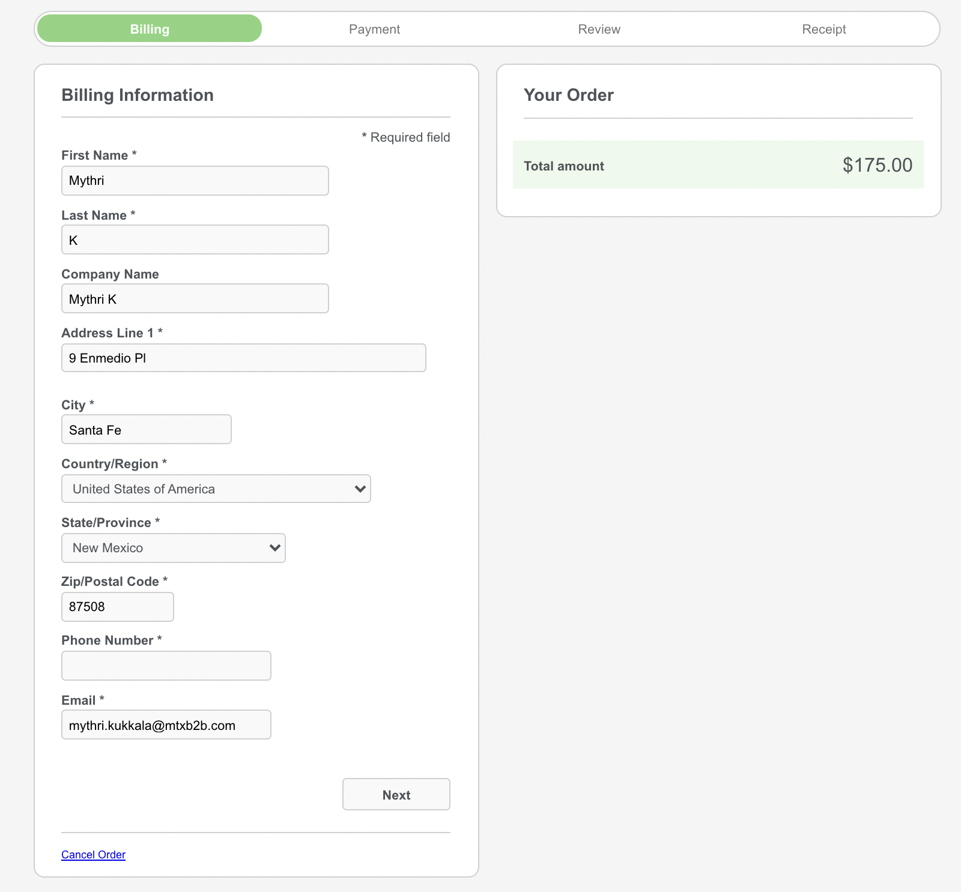
- Enter the payment details and click Next.
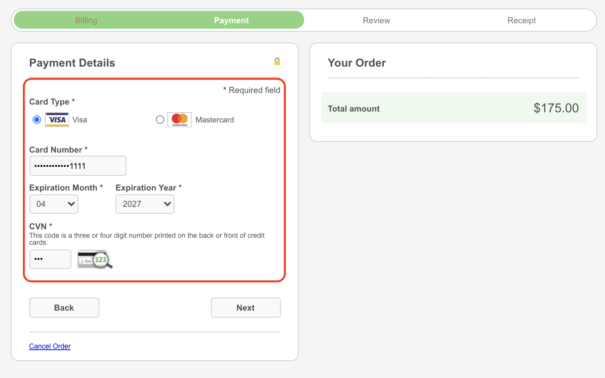
- Review the order and click Pay.
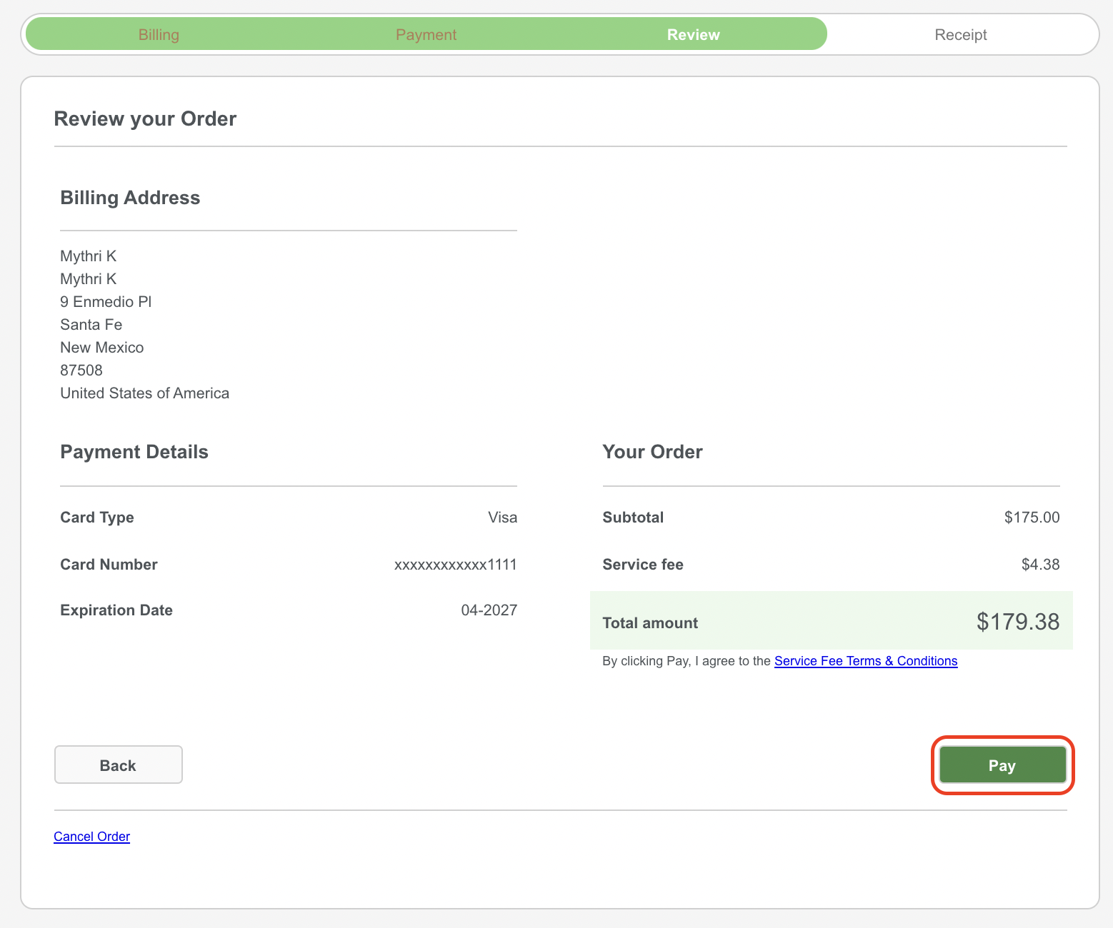
- A confirmation message will appear once the payment is complete.
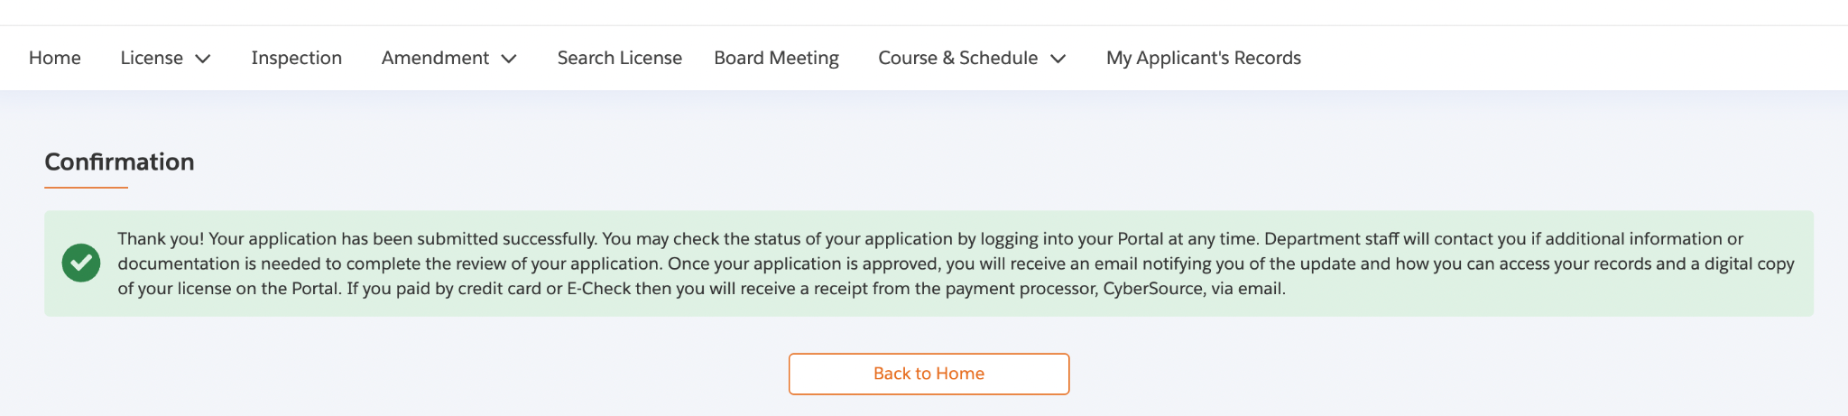
Note: You will receive a payment receipt to the email address you have entered in the Payment Gateway.

Checking Renewals Submissions
- On the home page, the renewal submission will appear under My Renewals with submitted status.
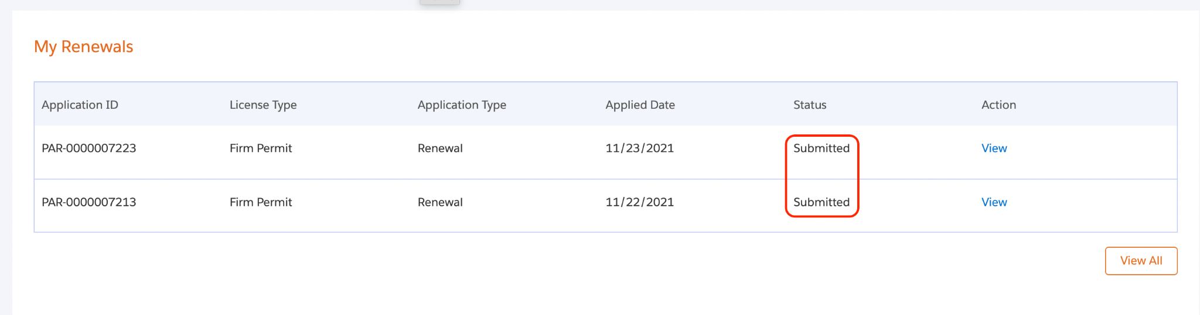
Note: The renewal application status changes to Active once the RLD team approves.
- Click on the Print button to generate a digital certificate (PDF) under My Licenses.
