-Page 16, Mini’s:
15.10.51.15 SALES OF CERTAIN SPIRITOUS LIQUORS:

I respectfully request a ruling for Twisted Shotz a 4 X 25ml (100ml) single pack, 20% ABV as a legal package to sell in NM retail liquor stores

Pictures of Twisted Shots for reference are below. A live sample pack can be sent if requested. 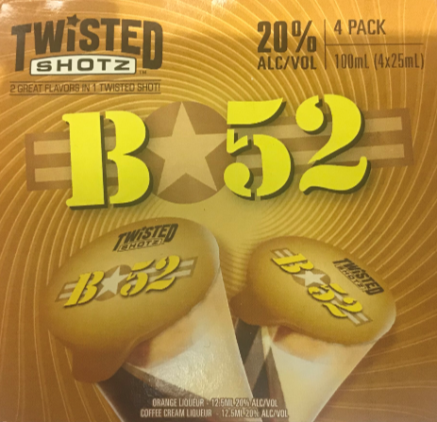
100ml size - 4 pack
